**Weapons Compliance Review Hearings**

**ALL Protection Order and Weapons Compliance Review hearings will be conducted by phone. Do not come to court in person!** Below is a quick checklist to help respondents better understand how to comply with the Order to Surrender Weapons and how to participate in telephone Weapons Compliance Review Hearing.

**In order to appear at your scheduled hearing, please contact the court at the following email address *at least one day before your hearing*:**  [weapons-surrender@kingcounty.gov](mailto:weapons-surrender@kingcounty.gov)

Please be sure to include in your email the following information:

✓ Your full name

✓ Date of your review hearing (this can be found in the upper right-hand corner of the Order to Surrender Weapons Order)

✓ The case name (for example: Smith vs. Smith)

✓ Your case number (this can be found in the upper right-hand corner of the Order to Surrender Weapons, for example: 19-2-12345-6)

✓ **A good phone number where you can be reached between 8:30am and noon on the day of your review hearing**

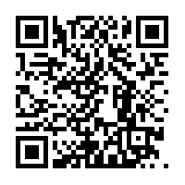**For more information about how to be in compliance with the Order to Surrender Weapons, please click on or search for the following link through your web browser:** https://bit.ly/3d9gHE4 **or scan the QR code with your smart phone:**

Court forms mentioned in the video, including the Declaration of Non-Surrender form (WPF All Cases 02-070) and the Proof of Surrender form (WPF All Cases 02-060), can be found at https://tinyurl.com/w7ou6ed